Documentary Workbook Treatment – Katie Gergel

Working Title: “Close Up on the Cape”

Summary: This documentary would focus on the Cape Cod National Seashore and the various wildlife rescue and conservation efforts that occur in the various towns of the Cape. Because this land in Massachusetts was set aside specifically by President John F. Kennedy to be a wildlife preserve that would go undisturbed by the commercialized building efforts that dominate a lot of other coastal areas, there are many different initiatives in place to keep the wildlife safe. This documentary would involve traveling to different parts of Cape Cod and highlighting stories of various species being saved.

Research: The Cape Cod National Seashore has 44,600 acres of raw, natural, preserved ecosystems that cover a range of habitats – from marine to terrestrial and everything in between. President John F. Kennedy signed a bill establishing this Cape Cod National Seashore on August 7, 1961.

The creation of the National Seashore has been the catalyst for a variety of organizations and institutions that want to further this mission of wildlife conservation and preservation. Some of these organizations are involved in cutting-edge research regarding wildlife education and development. Some of these organizations work to help wildlife that are sick or find themselves in danger. An overarching theme that unites them all is their motivation to learn about and protect the wildlife that has been able to thrive without threat of commercialization or tourism taking over the Cape Cod National Seashore.

Specific Organizations to Emphasize in Documentary:
- Cape Wildlife Center (Located in Barnstable, MA)
  - http://capewildlifecenter.com
  - Non-profit wildlife hospital and education center
  - Each year veterinary care is provided to 2,000 sick, injured, and orphaned wild animals
  - Works to educate members of the public and spread the message of environmental conservation
- International Fund for Animal Welfare (Located in Yarmouth, MA)
  - https://www.ifaw.org/united-states/our-work/whales/marine-mammal-rescue-and-research
  - Has a Marine Mammal Rescue and Research team that responds to animals in crisis along 700 miles of coastline in southeastern Massachusetts
- Wellfleet Bay Wildlife Sanctuary (Located in Wellfleet, MA)
  - https://www.massaudubon.org/get-outdoors/wildlife-sanctuaries/wellfleet-bay
  - Has research and conservation projects focusing on threatened shorebirds, Diamondback Terrapins, Horseshoe Crabs, and sea turtles
- Center for Coastal Studies (Located in Provincetown, MA)
  - http://coastalstudies.org
  - Conducts seal research
  - Has a water quality monitoring program
  - Has a marine animal entanglement response team dedicated to freeing animals caught in boat equipment or netting
- Wild Care (Located in Eastham, MA)
  - https://www.wildcarecapecod.org
  - Mission is to help sick, injured, and orphaned wildlife through Wildlife Rehabilitation; to reduce the number of animals impacted by human activity through Educational Outreach; and to help protect the species and the ecosystems they represent through Advocacy and Conservation
- National Marine Life Center (Located in Bourne, MA)
  - http://nmlc.org
  - Core mission is to rehabilitate and release stranded marine mammals and sea turtles

Information from the National Park Service about Cape Cod:
https://www.nps.gov/caco/learn/nature/animals.htm
- Over 450 species of amphibians, reptiles, fish, birds, and mammals depend on the ecosystems found at Cape Cod National Seashore
- There are 25 federally-protected species in the park
- Cape Cod National Seashore supports 32 species that are rare or endangered in the state of Massachusetts

Similar programs that could serve as inspiration for the documentary:
- Sea Turtle Rescue, Smithsonian Earth
  - Follows storylines of turtles who come in for rehabilitation at South Carolina Aquarium’s Sea Turtle Care Center
- Top 10 documentary films every conservationist should watch: https://www.conservation-careers.com/conservation-jobs-careers-advice/top-10-documentary-films-every-conservationist-watch/
  - The End of the Line
    - Shows the detrimental effects that overfishing has on global fish populations
  - Mission Blue
    - About the global initiative “Mission Blue” that is a campaign to create a global network of protected marine sanctuaries
  - Blackfish
    - Exposes the mistreatment of orcas in captivity at Sea World
    - Challenges us to consider our relationship with nature
    - Allows people to see the consequences of natural issues they may not have been aware of previously

Idea Development:

Idea change (12/2): Instead of having six separate stories that are highlighted one after the other (as I had originally planned; see episodes below), I think it would be more interesting for a feature length documentary to go back and forth between the different stories. Maybe choose two or three of storylines similar to the hypothetical ones that are outlined below and see the stories play out throughout the film simultaneously. This would keep audiences interested and it would not feel like three separate stories; instead, it would feel like on cohesive film.

Hypothetical documentary storylines that come from articles/blogs/research done regarding each of the centers highlighted:

“Swan Song Turned Love Story” – Cape Wildlife Center
A juvenile female swan is finally being released back into the wild after spending many weeks at the Cape Wildlife Center being treated for lead poisoning, a disease which unfortunately affects over 80% of the waterfowl population. This swan was one of the lucky ones to survive and make it back to her natural habitat on Mill Pond in West Yarmouth. It so happens that a male swan who had been living alone on Mill Pond for four years after losing his mate comes into contact with the recently released female. They mate and stay bonded – a story that turns from hopeless to hopeful for both creatures.

“Saving a Stranded Dolphin” – International Fund for Animal Welfare
It’s an evening in the summer and the Marine Mammal Rescue and Research team in Yarmouth get a call from two beachgoers who find a small dolphin stranded on the seashore. The team mobilizes right away to find this dolphin, who has beached itself after suffering from disorientation caused by becoming entangled in fishing gear and being separated from its group. The team loads the dolphin into their trailer and transports them across land to a beach with deep water access. In the trailer, the dolphin receives a health assessment and is treated with the necessary fluids and medicines. Before releasing the rehabilitated dolphin back into the deep water, the team tags it with a small temporary transmitter to assess how the dolphin is faring after it rejoins its ocean habitat.

“The Endangered Diamondback Terrapins” – Wellfleet Bay Wildlife Sanctuary
A female diamondback terrapin has been spotted by volunteers at the Wellfleet Bay Wildlife Sanctuary. She has just laid eggs in a nest at high risk of being predated upon by the variety of species that feed on terrapins. Volunteers work to protect and track the nest and the terrapin mother until the hatchlings are born – alive and healthy – and released around the sanctuary and the satellite monitoring sites, joining the over 3,000+ hatchlings that have been saved by the Wellfleet Bay Wildlife Sanctuary since 2016.

“The Humpback Disentanglement” – Center for Coastal Studies
The Center for Coastal Studies’ Marine Animal Entanglement Response crew gets a report from a Hyannis Whale Watcher Cruises vessel about an entangled whale a few miles off of Provincetown. The crew responds right away and sails to the location of the humpback whale, which is found to have a fishing line going from its mouth to the tail stock. The crew works to remove the line, freeing the whale to swim away and rejoin its natural ocean habitat.

“Baby Robin Finds a Home” – Wild Care
Wild Care receives a small fledgling American Robin who is suffering from a variety of challenges, including weakness, dehydration, a twisted foot, a wind droop, possible blindness in one eye, and ruptured air sacs. It is evident right away that with this level of injury, this robin will not make it if it is released back into the wild. However, the workers at Wild Care do not give up on the poor creature. They wrap the foot in a flat splint that corrects its twisted foot, and the air sacs and wing droop issues resolve with rehabilitation. Though the robin still cannot be released back into the wild, it finds a new home at Drumlin Farm, a Mass Audubon Wildlife Sanctuary that teaches wildlife conservation. The little bird finds its place among the other songbirds in the sanctuary.

“Charlie’s Road to Recovery” – National Marine Life Center
Charles “Charlie” was the first harbor pup of the 2018 season, coming to the National Marine Life Center from Ellisville, Plymouth where his mother had abandoned him. He was born premature and was rescued at just 2 feet and 13 pounds. Since he first came to the NMLC, he has been receiving top notch care from veterinarians at the clinic. As of July 19th, he has developed enough muscle to sustain extended period of exercise, and he loves swimming in the pool with his pool mates. Over the past couple of months, he has been treated for influenza and a corneal ulcer. He has since regained his health and just needs to gain more weight before he is released.

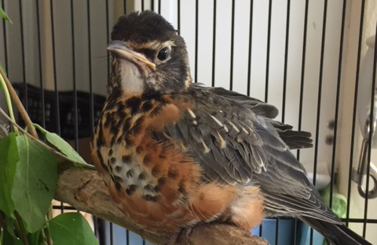
Visual References:
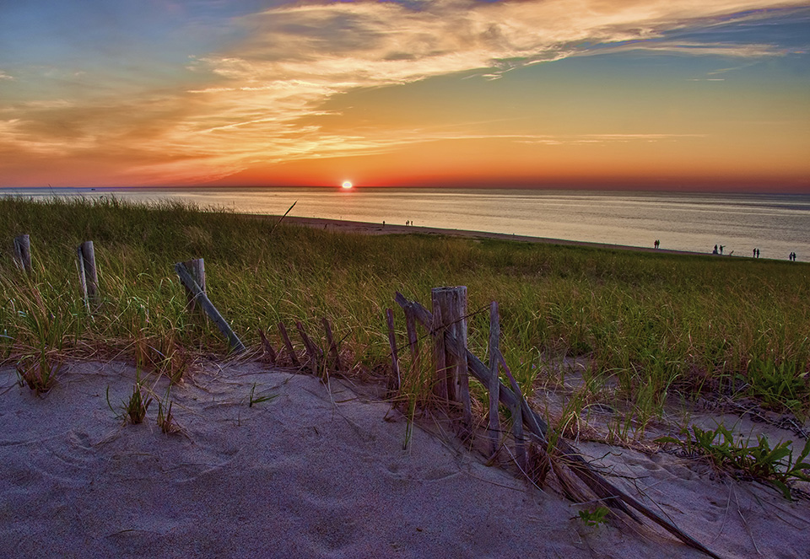
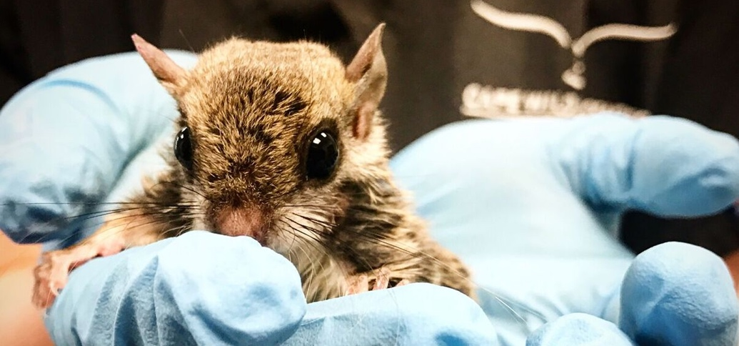
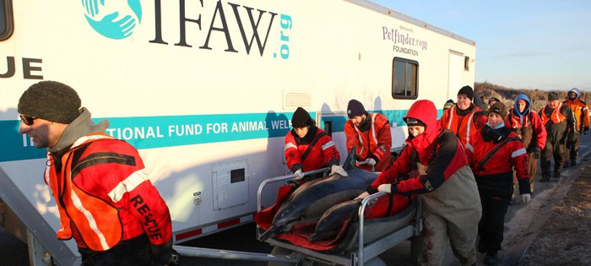

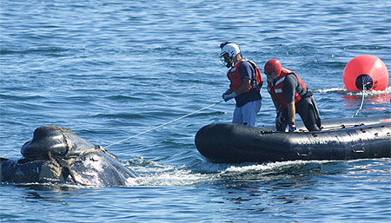
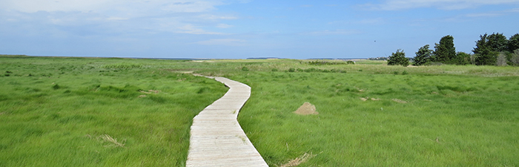

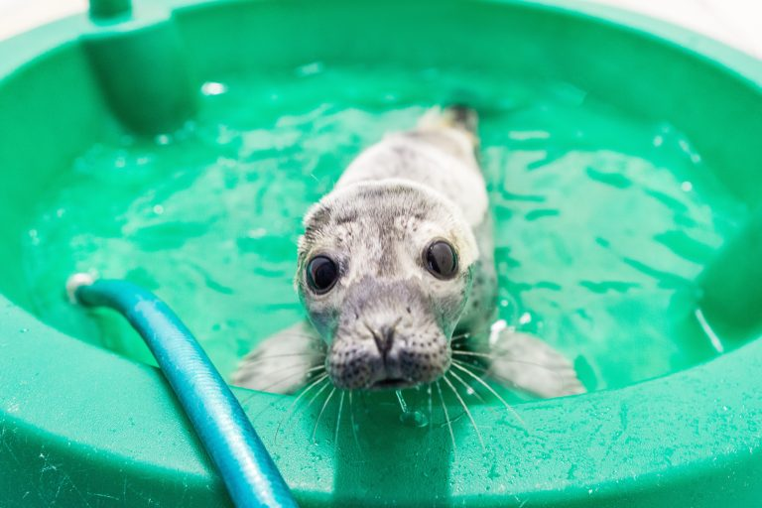
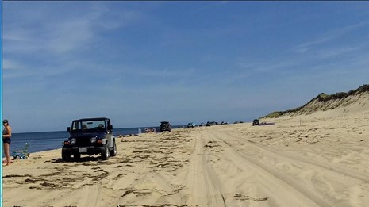

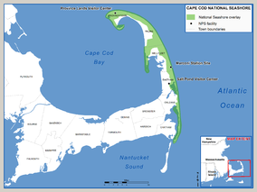

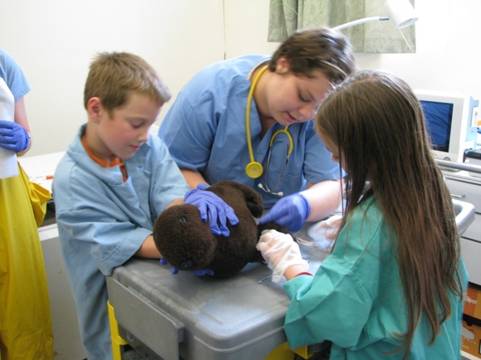

Writer’s Journal Entries:

- Cape Cod is a place that I am extremely passionate about. I have gone there nearly every summer of my life since I was born and I have been able to witness firsthand the wildlife conservation efforts that go on every day. One day I was on a Whale Watch boat trip and we came across a whale that had been tangled in a boat’s netting. A rescue team came out to free the whale, and it was one of the most interesting and exciting things that I have ever witnessed. I think more people deserve to know about the conservation efforts that go on every day in Cape Cod, and a documentary would be a really cool way to highlight specific places and specific storylines. Who doesn’t love a baby animal being rescued? I’m looking forward to seeing how these basic storylines that I have come up with will develop and combine into a cohesive and interesting full documentary story.

- I worked this summer at the Smithsonian Channel, and one of the programs that my supervisor was highly involved in was a series on Smithsonian Earth called “Sea Turtle Rescue.” The series took place at the South Carolina Aquarium’s Sea Turtle Care Center, and it followed the storylines of different sea turtles who were injured and had to be brought into the hospital for re-habilitation. This series really inspired me as I was writing this documentary treatment. Not only would something like this – conservation efforts for species in Cape Cod – be interesting to watch, it would also bring awareness to these different organizations who are putting in incredible work each day to make sure that habitats, ecosystems, and individual animals are healthy and safe.

- As I was doing research about different programs that could serve as inspiration for my documentary on Cape Cod, I came across an article that mentioned the documentary “Blackfish.” I remember watching this documentary with my mom a few years back and being profoundly affected by it. Some of the images that were shown will never get out of my head, such as the sequence showing how baby orcas are separated from their mothers and the emotional turmoil it causes both of them. Documentaries like “Blackfish” are so important because they make people aware of issues that they may never have even considered before. That is the vision that I have for “Close Up on the Cape” – maybe it would make viewers more aware of the consequences that their actions can have on the surrounding ecosystems: trash, pollution, dangerous netting in the water, etc.

- I really like the idea that I came up with when it comes to combining maybe two or three of the hypothetical storylines that I came up with so that they would occur simultaneously in a feature length documentary film. Obviously if this film were actually being made the storylines to be followed would heavily depend on circumstance: what kind of animal rescues were happening that time frame in which it would be filmed? I do think this idea of combining the stories and following perhaps three at the same time, though, would make for a much more cohesive documentary that is interesting, easy to follow, and unique.

- I’m really happy with how this documentary treatment came out. As I was working on it, a lot of the different potential storylines kept striking me as I looked further into the different conservation organizations and read articles about real efforts they had performed in the past. Like I said in my first journal entry, this documentary would be appealing because who doesn’t love seeing the rescue of a baby animal? I feel like this is a topic that people would watch a fictional narrative film about, and it makes it all the better when you know that the rescue efforts are happening in real life. I really saw my ideas change and develop as I worked through this and conducted research, and I think the final product of the summary, hypothetical storylines, visual references, and inspirations really came out as I had wanted it to.

